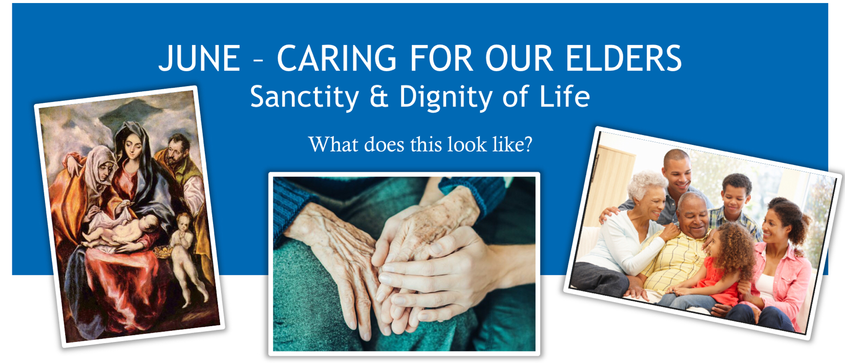
The month of June we focus on the care of the elder in our lives. We look to the 4th commandment to honor your father and mother at all stages of life, respecting the dignity and sanctity of life until natural death.
Adult children of elderly parents are asked to care for them with a generous heart. “Listen to your father who begot you, / and dispose not your mother when she is old” Proverbs 23:22

Pray for the Elderly
O loving St. Anthony, patron saint of the elderly, I ask your special prayers for (name person) and all elderly people.
Pray, beloved saint, that they are grateful for the years they have lived, content with their place in life, have hearts and minds that are full of happy memories and thankful thoughts, that they are blessed with good health, and that they are examples of Christian living for all they love and meet.Please pray that if they are tested with illness, suffering, loneliness, or the death of loved ones that they be blessed with God’s peace and comfort, strength and courage.And when their time comes to enter into eternal life, I pray you welcome them into Heaven where along with you they might praise God forever and ever, Amen.

Reflect The Christian home is the place where children receive the first proclamation of the faith. For this reason, the family home is rightly called “the domestic church,” a community of grace and prayer, a school of human virtues and of Christian charity.
• Where there is a need for the care of the elderly within my own family and
community?
• Am I modeling to my children and community the virtues of charity, empathy and
compassion that respect the sanctity of life of the elderly and aging?
• Am I selecting leadership that follow church teaching to honor the dignity and
sanctity of life from natural conception to natural death?
Act
- Light a candle and pray for the elderly in your life
- Volunteer at a local Hospice facility, Meals On Wheels, and OLV Helping Hands Ministry
- Write letters of encouragement or have your children draw pictures for the local nursing home residents

You can make a difference!
For resources visit northerncoloradoforlife.com

