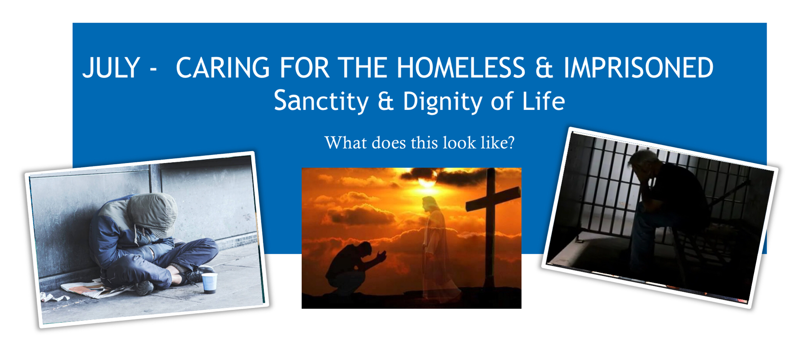
In the month of July, Sanctity and Dignity of Life focuses on the homeless and imprisoned through the works of mercy. The works of mercy are charitable actions by which we come to the aid of our neighbors in his spiritual and bodily necessities. Instructing, advising, consoling, comforting are spiritual works of mercy , as are forgiving and bearing wrongs patiently. The corporal works of mercy consists especially in feeding the hungry , sheltering the homeless, clothing the naked, biting the sick and imprisoned, and burying the dead. Among all these, giving alms to the poor is one of the chief witnesses to fraternal charity: it is also a work of justice pleasing God. (CCC2447)

Pray for the homeless and imprisoned
Let us pray, oh Jesus you told us. “Truly I tell you, whatever you do for the least of my brothers and sisters of mine, you do for me.” Help us to reach out and give to those who ask us whatever we can- be it our time, talent, or treasure. Lord, show us how to best imitate your love and mercy to the homeless and imprisoned. We ask this in your name and for your sake, Amen.

Reflect “If I had to start all over again, I would do the same thing. I have experienced many human weaknesses, many human frailties, and I still experience them, but we need to use them. We need to work for Christ with a humble heart, with the humility of Christ. He comes and uses us to be his love and compassion in the world in spite of our weaknesses and frailties. – Saint Teresa of Calcutta
How will you answer God’s call to what he is asking you to do ?
Act This month pray about what you and your family are called to do to take action
- Volunteer/Donate at the Guadalupe Center in Greeley (Donation link on OLV website)*
- OLV Stephen’s ministries serves the imprisoned. Are you being called to join this ministry?
- Organize and participate in fundraisers to purchase bibles for prisoners *
- Volunteer/Donate to the Samaritan House in Fort Collins
- Make Hygiene bags for the homeless*
(* family friendly)

You can make a difference!
For resources visit northerncoloradoforlife.com

